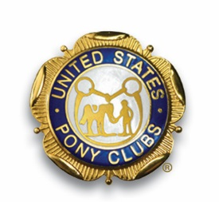
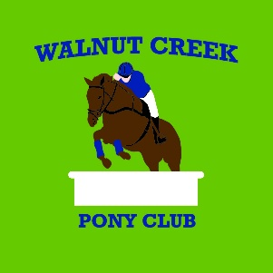

United States Pony Club Midsouth region

Greater Cincinnati

Susan Colliver
Walnut Creek Pony Club, Chairperson
9531 Dick Rd
Harrison, Ohio 45030
513-675-2403

February, 2022

Dear Friend,

Since 1954, The United States Pony Clubs has been providing youth across the country with the skills to become successful adult leaders to not only in the equine world, but in whatever field they may choose. Thank you for your support of our programs and our members.

Walnut Creek Pony Club has been a part of United States Pony Clubs for over 25 years.

The members of Walnut Creek Pony Club and I would like to thank you for your donation to our silent auction fundraiser. We depend on support from generous people like you for this event. This year, the funds raised will be used for clinics and other educational programs for our youth and adult members. Remember, your donation is tax deductible under IRS Code 501(c)(3).

It is truly gratifying to see businesses and friends such as you support the Pony Club and our efforts toward the growth and encouragement of our members. Thank you for your generosity.

Sincerely,
Susan Colliver

Susan Colliver

Susan Colliver-Chairperson- DC (District Commissioner)
Walnut Creek Pony Club
Mid-South Region
9531 Dick Rd.
Harrison, Ohio 45030
513-675-2403

Donation Value _________________________

